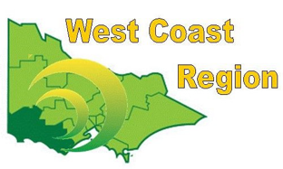
WEST COAST BOWLS REGION INC
WOMEN’S NOVICE SINGLES
2012-13 | Wendy Colcott | Grangeburn | FWBD
2013-14
2014-15 | Debbie Linton | Colac | CBD
2015-16 | Mavis Harling | Colac | CBD
2016-17 | Glenys McNabb | Colac | CBD
2017-18 | Nola Curran | Hamilton | FWBD
2018-19
2019-20 | Linda Gilbert | City Memorial | WDBD
2020-21 | Lorraine Battye | Birregurra | CBD
2021-22 | Sharon Bennett | Colac City | CPA
2022-23 | Jodie Bertrand | Apollo Bay | CPA
2023-24 | NOT HELD
2024-25 | Avril Ross | Penshurst | FWPA

