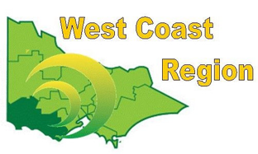
WEST COAST BOWLS REGION INC
WOMEN’S FOURS
2012-13 | Kerrie Alexander  Joy Werner  Shirley Roger  Shirley Millard | Portland | FWBD | State RUNNER UP
2013-14 | Kerry Alexander  Joy Werner  Shirley Roger  Shirley Millard  (s) Robyn Pumpa  (s) Marie Benbow | Portland | FWBD
2014-15 | Maureen Drennan  Dorothy Gleeson  Sheridan Barling  Faye Bolden | Composite | WDBD
2015-16 | Carol Harbor  Leeanne Fitzgerald  Hilda Bentley  Joan Lawrence | Colac City | CBD
2016-17 | Robyn Thomassen  Irene McGrath  Wendy Colcott  Beryl Povey | Grangeburn | FWBD
2017-18 | Maureen Drennan Sherdian Barling  Polly Rabl  Gayle Taylor | Dennington | WDBD
2018-19 | Glenda Gourley  B Dillon  Leona Pekin  Carmel Watson | Colac | CBD
2019-20 | Pauline Burleigh  Julie Dosser  Moira Cooknell  Kate Lloyd | City Memorial | WDBD
2020-21 | Robyn Thomassen  Leonie Buchanan  Ann Rentsch  Leah McCabe | Composite | FWBD
2021-22 | Pauline Burleigh  Julie Dosser  Caseylee Sheehan  Moira Cooknell | City Memorial | WDBD
2022-23 | Julie Dosser  Kate Lloyd  Moira Cooknell | City Memorial | WDBD
2023-24 | Maria van Someren  Leeanne Fitzgerald  Kathy Leslie  Vicki Brebner | Composite | CPA
2024-25 | Rebecca McMahon  Hayley Murnane  Jodie Bertrand  Erin Baulch | Composite | CPA

