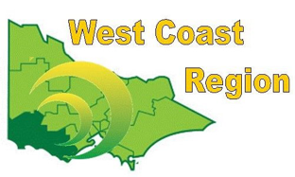
WEST COAST BOWLS REGION INC
WOMEN’S TRIPLES
2012-13 | Maureen Drennan  Dorothy Gleeson  Val Hassell | Composite | WDBD
2013-14 | Kellie Bowles  Pat Boyd  Hannah Mitchell | Warrnambool | WDBD
2014-15 | Linda Creek  Gill Vorwerk  Diane Mugavin | Composite | WDBD
2015-16 | Maureen Drennan  Lorraine Frewin  Julie Dosser | Composite | WDBD
2016-17 | Leonie Buchanan  Heather Burgess  Jan Woolley | Composite | FWBD
2017-18 | Robyn Thomassen  Leah McCabe  Beryl Povey | Grangeburn | FWBD
2018-19 | Coral Hanson  Val Hutchison  Kathy Leslie | Colac City | CBD
2019-20 | Leonie Buchanan  Heather Burgess  Coral Barbary | Composite | FWBD
2020-21 | Sheridan Barling  Polly Rabl  Gayle Swanson | Dennington | WDBD
2021-22 | Sheridan Barling  Polly Rabl  Gayle Swanson | Dennington | WDPA
2022-23 | Maureen Drennan  Julie Dosser  Caseylee Sheehan | City Memorial | WDPA
2023-24 | Rebecca McMahon  Hayley Murnane  Jodie Bertrand | Composite | CPA
2024-25 | Caseylee Sheehan  Julie Dosser  Moira Cooknell | City Memorial | WDPA

