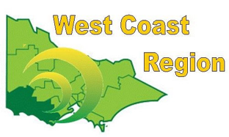
WEST COAST BOWLS REGION INC
WOMEN’S SINGLES
2012-13 | Kellie Bowles | Warrnambool | WDBD
2013-14 | Joy McGrath | Portland | FWBD
2014-15 | Kellie Bowles | Warrnambool | WDBD
2015-16 | Kellie Bowles | Warrnambool | WDBD
2016-17 | Joy McGrath | Portland | FWBD
2017-18 | Robyn Thomassen | Grangeburn | FWBD
2018-19 | Maureen Drennan | Dennington | WDBD
2019-20 | Sheridan Barling | Dennington | WDBD
2020-21 | Maureen Drennan | Dennington | WDBD
2021-22 | Sue Kerr | Colac Central | CPA
2022-23 | Maureen Drennan | City Memorial | WDPA
2023-24 | Rebecca McMahon | Colac CIty | CPA | State Runner up
2024-25 | Stephanie Hunt | City Memorial | WDPA

