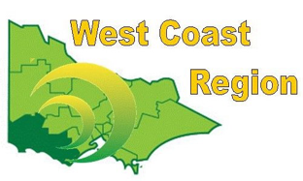
WEST COAST BOWLS REGION INC
WOMEN’S PAIRS
2012-13 | Kellie Bowles  Pat Boyd | Warrnambool | WDBD
2013-14 | Irene McGrath  Wendy Colcott | Grangeburn | FWBD
2014-15 | Jill Rantall  Noelene Tolland | Camperdown Golf | CBD
2015-16 | Kerrie Alexander  Shirley Millard | Portland | FWBD
2016-17 | Pearl McIver  Mavis Harling | Colac | CBD
2017-18 | Rebecca McMahon  Lee anne Fitzgerald | Colac City | CBD | STATE CHAMPIONS
2018-19 | Rebecca McMahon  Lee anne Fitzgerald | Colac City | CBD
2019-20 | Kerrie Alexander  Shirley Millard | Portland | FWBD
2020-21 | Pauline Burleigh  Kate Lloyd | City Memorial | WDBD
2021-22 | Robyn Thomassen  Leah McCabe | Grangeburn | FWPA
2022-23 | Heather McIntyre  Barb Moore | Composite | FWPA
2023-24 | Stephanie Hunt  Casylee Sheehan | City Memorial | WDPA
2024-25 | Stephanie Hunt  Maureen Drennan | City Memorial | WDPA

