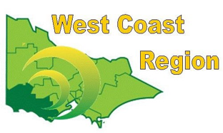
WEST COAST BOWLS REGION INC
MIXED PAIRS
2012-13
2013-14
2014-15 | Kevin O’Keeffe  Pauline Burleigh | City Memorial | WDBD
2015-16 | Peter Webster  Wendy Webster | Portland | FWBD
2016-17 | Don Price  Wendy Jelbart | City Memorial | WDBD
2017-18 | Des Pitts  Kim Overall | Portland RSL | FWBD
2018-19 | Shane Cashill  Sue Kerr | Colac Central | CBD
2019-20 | Tom Englezos  Kim Overall | Portland RSL | FWBD
2020-21 | James Barling  Sheridan Barling | Dennington | WDPA
2021-22 | George Draffen  Jacinta Mahney | Mortlake | WDPA
2022-23 | Les Johnson  Betty Johnson | Composite | WDPA
2023-24 | Peter Merryfull  Jenny Mutch | Balmoral | FWPA
2024-25 | Michael Funcke  Stephanie Funcke | Koroit | WDPA

