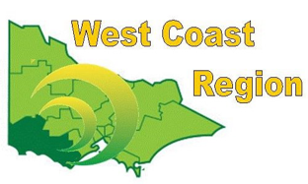
WEST COAST BOWLS REGION INC
MEN’S PAIRS
2012-13 | Danny Donovan  Ernie Andres | Colac | CBD
2013-14 | Neil Crispe  Peter Pangrazio | Warrnambool | WDBD
2014-15 | Graeme Solly  Matt Solly | Portland RSL | FWBD | STATE WINNER
2015-16 | Ken Bell  Tim Jackway | City Memorial | WDBD
2016-17 | Jeff Turner  Anthony McKay | Colac | CBD
2017-18 | Graeme Solly  Tom Englezos | Portland RSL | FWBD
2018-19 | Neil Crispe  Tom Pemberton | City Memorial | WDBD
2019-20 | Les Johnson  Wayne Cooper | Koroit | WDBD
2020-21 | Danny Donovan  Ken Hanson | Composite | CBD
2021-22 | Ricky Angelino  Neville Trotman | Composite | FWBD
2022-23 | Ron Cameron  Gary Body | Composite | CPA
2023-24 | Will Collihole  Tim Hassett | Colac | CPA
2024-25 | Graeme Solly  Kelvin Wiffen | Composite | FWPA

