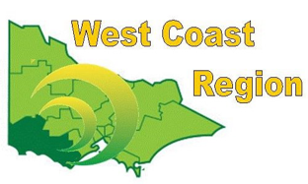
WEST COAST BOWLS REGION INC
MEN’S SINGLES
2012-13 | Barry Crimmin | Warrnambool | WDBD
2013-14 | Neil Crisp | Warrnambool | WDBD
2014-15 | Arthur Finch | Timboon | WDBD
2015-16 | Gary Body | Camperdown | CBD
2016-17 | Jack Murnane | Koroit | WDBD
2017-18 | Arthur Finch | Timboon | WDBD
2018-19 | Les Johnson | Koroit | WDBD
2019-20 | Neil Crisp | City Memorial | WDBD
2020-21 | Rhys Jeffs | Winchelsea | CBD
2021-22 | Peter Inglis | Simpson | CBD
2022-23 | Scott Boschen | Koroit | WDPA
2023-24 | Scott Boschen | Koroit | WDPA
2024-25 | Will Collihole | Colac | CPA

