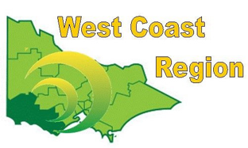
WEST COAST BOWLS REGION INC
MEN’S CHAMPION OF CHAMPIONS
2012-13 | Ian Johnson | Colac City | CBD
2013-14 | Will Collihole | Colac | CBD
2014-15 | David Wells | City Memorial | WDBD | STATE CHAMPION
2015-16 | Peter Webster | Portland | FWBD
2016-17 | Peter Inglis | Simpson | CBD
2017-18 | David Wells | City Memorial | WDBD
2018-19 | Richard Martin | Hamilton | FWBD
2019-20 | Rhys Jeffs | Winchelsea | CBD | STATE CHAMPION
2020-21 | Rhys Jeffs | Winchelsea | CBD
2021-22 | Will Collihole | Colac | CPA
2022-23 | Luke Wright | Camperdown | CPA
2023-24 | Rhys Jeffs | Winchelsea | CPA
2024-25 | David Wells | City Memorial | WDPA

